Final Project Report

**Objective:** This analysis proves how customer demographics, such as marital status, educational qualification, and income, affect order frequency, order size, total spend, and the cost of orders, while the distribution of orders varies across different days of the week and months, exhibiting seasonal trends.

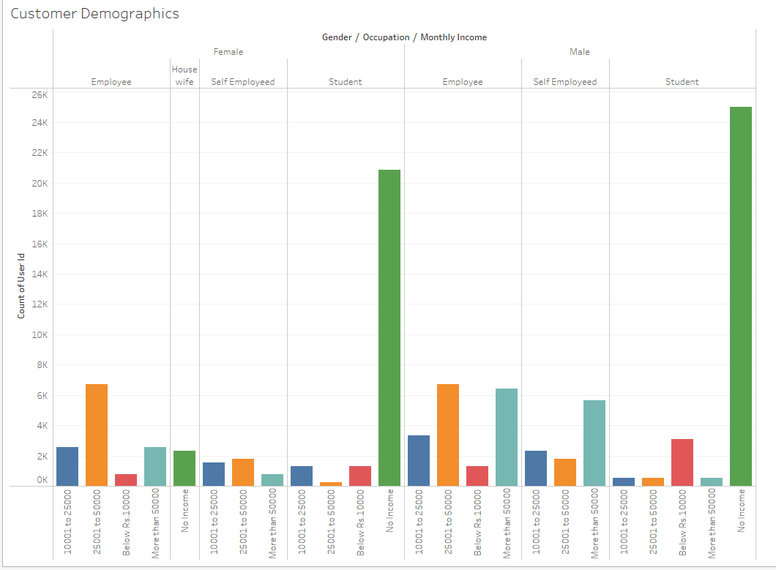

* Male students with no income usually place the most orders, even with limited money.
* Female students with an income between 25,001 and 50,000 tend to place the fewest orders, possibly due to their moderate income.
* Employees generally place the most orders, showing that those with stable jobs tend to order more.

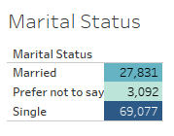

* Single people tend to place more orders than married individuals, likely due to more flexibility or disposable income.
* Those in other relationship statuses generally place the fewest orders.

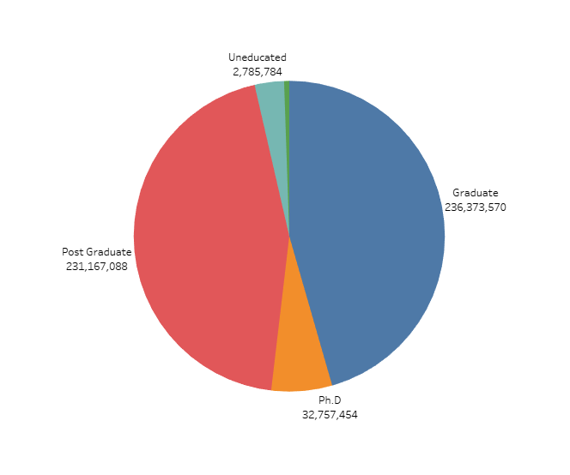

* Graduates have the highest total spend at the restaurant, placing the most orders overall, likely due to higher incomes and established careers.
* Postgraduates follow closely, with a substantial number of orders, indicating strong purchasing activity, though slightly lower than graduates.
* Ph.D. holders tend to place less expensive orders than postgraduates, while school students and uneducated individuals place the least, with the lowest total spend and order frequency.

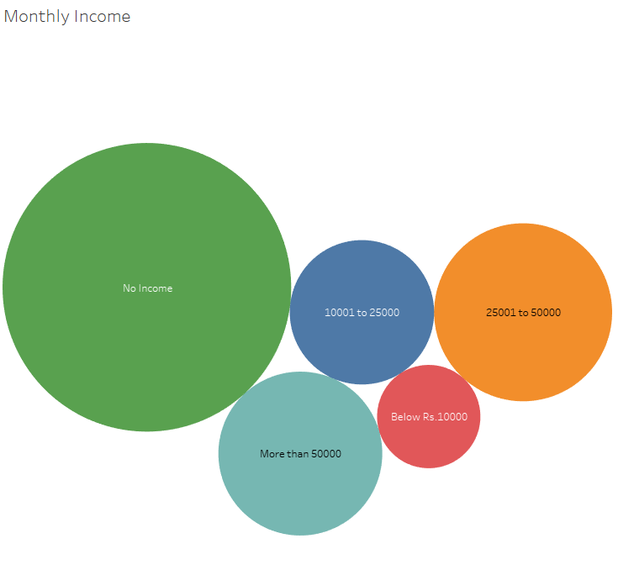

* People with no income generate the highest sales, possibly due to unique purchasing behaviors or reliance on other financial sources.
* Individuals earning between 25,001 and 50,000 contribute a strong amount to sales, placing a significant number of orders.
* Those earning over 50,000 follows, with slightly lower sales than the previous group, but still maintaining a solid level of spending.
* People earning between 10,001 and 25,000 make fewer purchases, resulting in a moderate contribution to sales.
* Individuals with incomes below 10,000 contribute the least to sales, likely due to limited spending capacity.

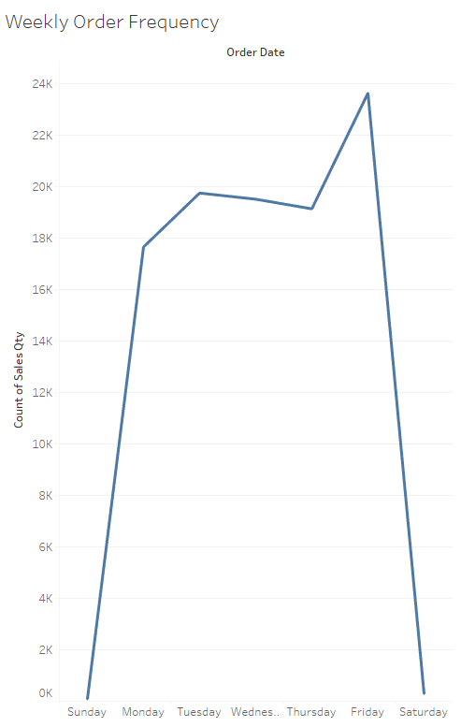

* Friday has the highest number of orders, likely due to people unwinding at the end of the workweek and choosing to dine out.
* Tuesday, Wednesday, and Thursday follow closely, with more people dining out during the weekdays than on weekends.
* Monday sees a slight drop in orders as people adjust to the workweek, while Saturday experiences fewer orders due to weekend activities.
* Sunday has the least orders, likely because many people prefer relaxing at home with family rather than dining out.

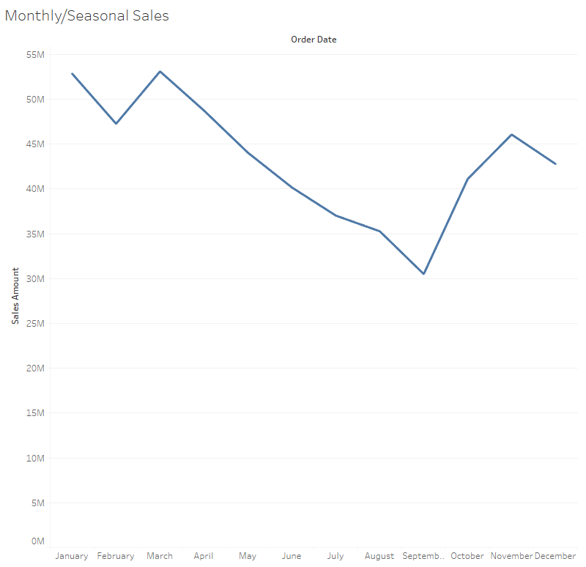

* March has the highest restaurant spending, with over $53 million, followed closely by January at over $52 million, driven by New Year celebrations.
* April sees over $48 million, and February brings in over $47 million, largely due to Valentine’s Day dining.
* November and May generate over $46 million and $44 million, respectively, with holidays like Thanksgiving and spring events boosting sales.
* December totals over $42 million, driven by holiday parties and year-end gatherings, while October and June see over $41 million and $40 million, influenced by autumn events and summer vacations.
* July and August bring in over $37 million and $35 million, as people enjoy summer dining, and September has the lowest sales, just over $30 million, marking a post-summer dip.
* Key holidays like Valentine’s Day, Thanksgiving, and New Year’s result in significant spikes in dining out.

Conclusion:

* Having more restaurants near schools could increase sales, especially from male students.
* Raising prices on weekdays, particularly Fridays, could lead to higher earnings.
* Expect to see singles with little or no income eat out more on weekends, while married couples and families often prefer dining at home.